**MCTE 4342 EMBEDDED SYSTEM DESIGN**

**NAME: MUHAMMAD IZZAT BIN MOHD ISA**

**MATRIC NO: 1717987**

**SECTION: 1**

**QUESTION 1**

a) In Quantum Sensors Could Let Autonomous Cars ‘See’ Around Corners, the role of the embedded system is to design a system and controller to control the car by itself that communicates between another embedded system. The example of embedded systems that are being used in autonomous cars is the **Engine Control Unit (ECU)**, **Global Positioning System (GPS)** **and Radar System**, and **Digital Controlled Braking System**. All of these embedded systems communicate with each other and also with cameras and sensors such as Light Detection and Ranging (LIDAR) or sonar sensors.

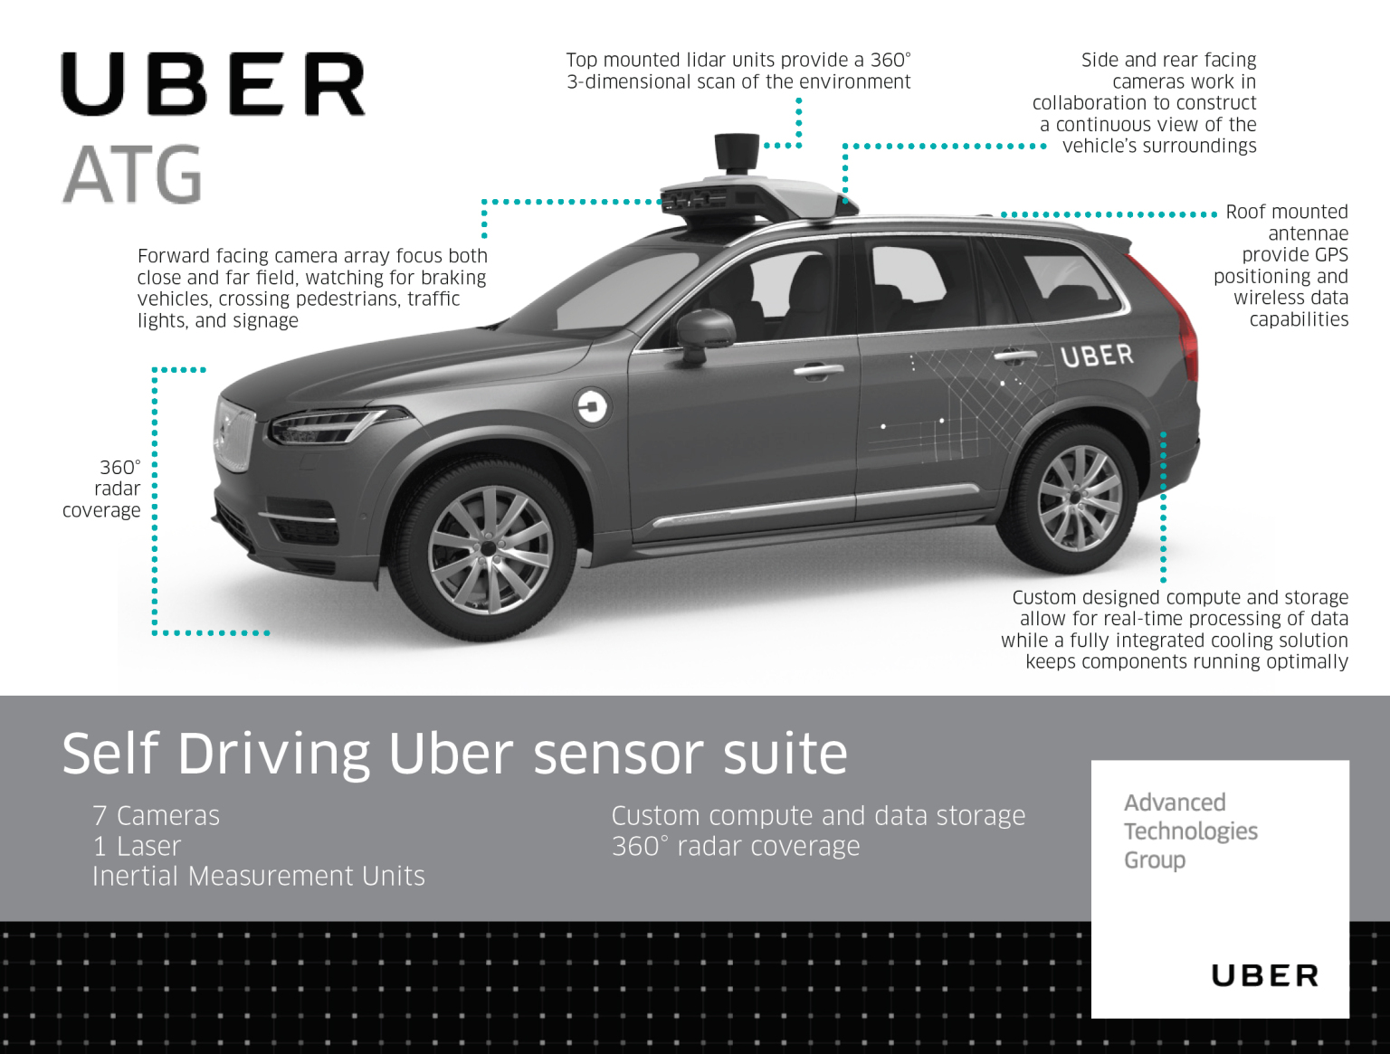

Example above shows the Uber autonomous car that was currently being tested on America public roads.

Embedded System List

i) **ECU**

These cars used the ECU to control all the series of actuators and also the internal combustion engine to ensure optimal engine performance.

- 360 Radar System and Camera

These cars also have a 360 radar coverage system to detect the obstacle and blind spot around the car with the help camera to process and identify the type of obstacle.

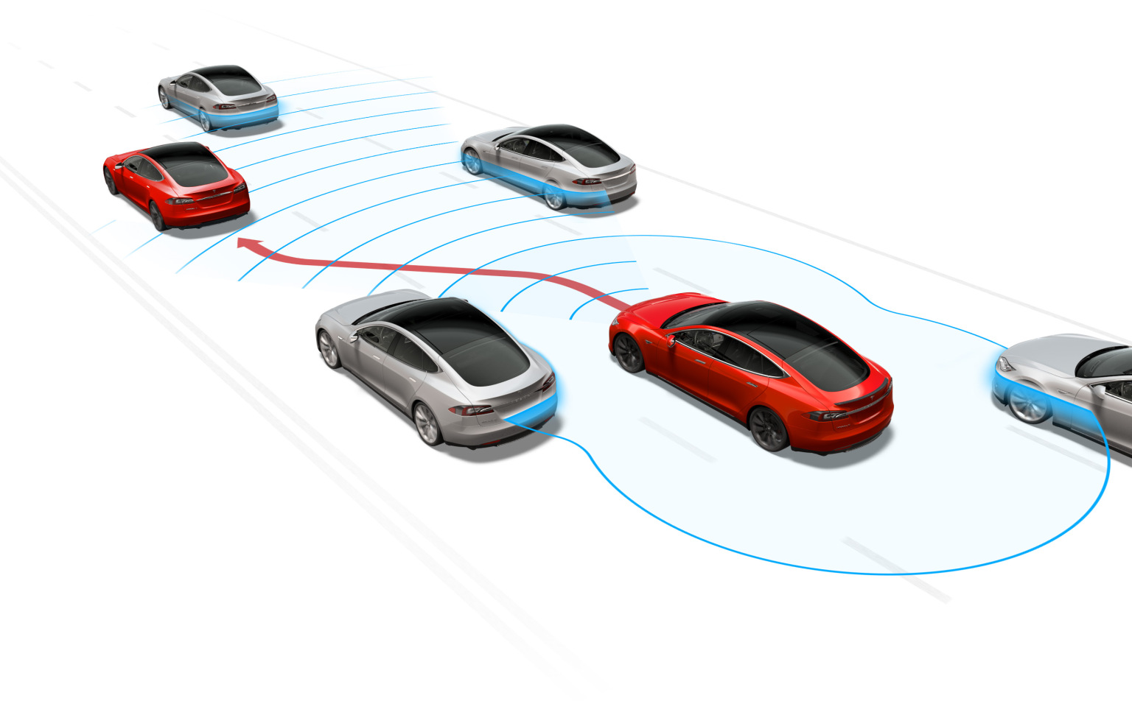

*Radar Working Principle Illustration*

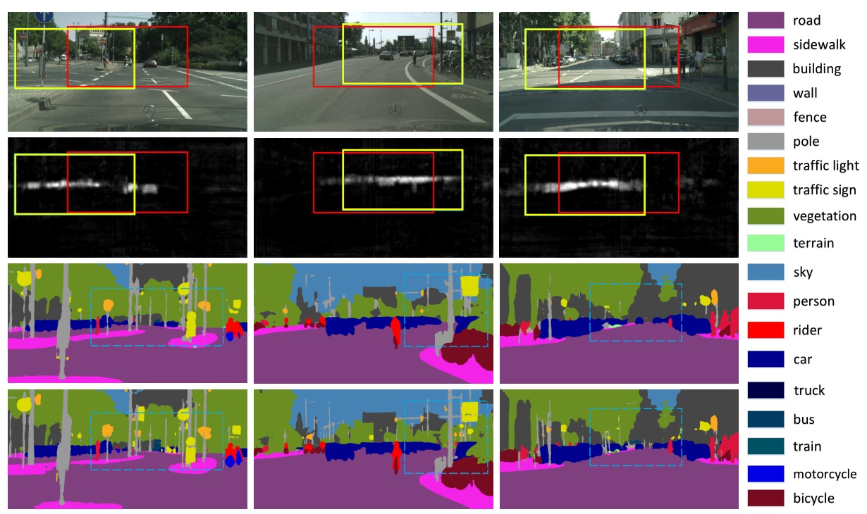

*Camera Vision Output*

- LIDAR Sensor

Also, the LIDAR sensor was used to construct 3D image mapping of the vehicle’s surroundings and calculate the real-time range of objects that are further down the road relative to the car.

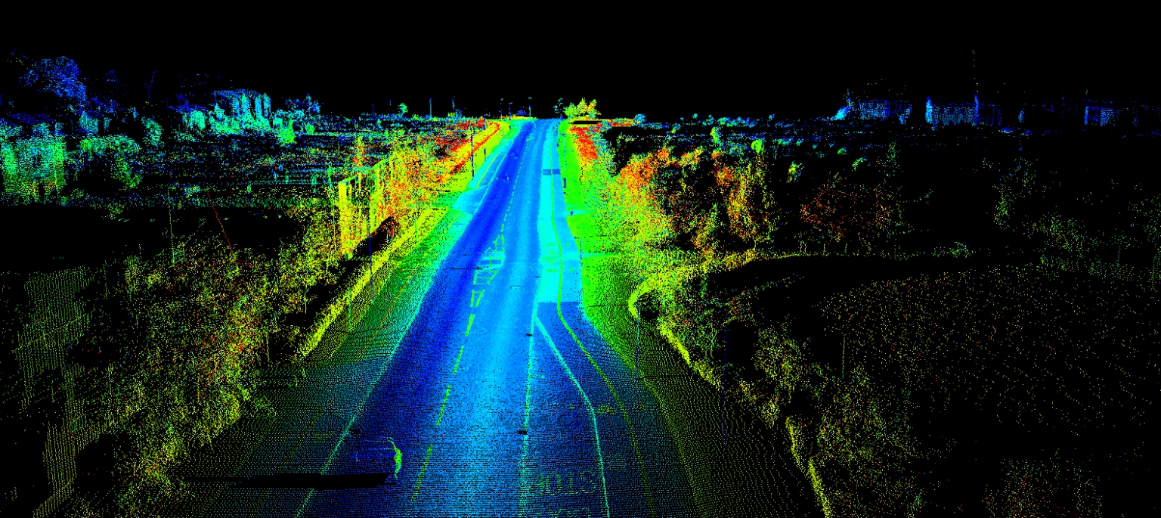

*Example of LIDAR image visualization*

Based on all this info, it will help the ECU to decide and command all the actuators and systems that control the car.

ii) **Global Positioning System (GPS)**

The GPS was used to tell the route that the car should go and calculate the estimation time of arrival.

iii) **Digital Controlled Braking System**

The braking that was communicated directly with the ECU to control the speed of the vehicle based on the obstacle and surrounding of the vehicle.

Currently, the car is still in the testing and developing stage. Uber is pursuing to commercialize the car and sell it all around the world. Tesla is also doing the same but they are replacing the LIDAR with the sonar sensor.

b) In Electric Aviation Could Be Closer Than You Think, the role of embedded systems is to enable planes to do critical tasks (taking-off and landing) and communicate with each other (plane and control tower). The example of a related embedded control system is **the Flight Control Embedded System (FCS)** and **the Air Traffic Control Embedded System (ATCS)**.

Embedded System Component List

i) **Flight Control Embedded System (FCS)**

The function of FCS is to maintain the flight trajectory and the stability of the airplane by controlling all the actuator and component shown in the image below.

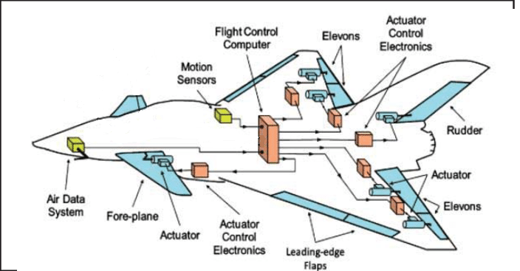

*Flight Control Embedded System Illustration*

In other word, all the components are always communicating with the FCS simultaneously. For example, the radar altimeter and motion sensor (gyroscope and accelerometer) give all the information and data to the FCS and then the FCS will command all related actuators to ensure the altitude and orientation of the plane is ideal. The FCS is crucial that it should meet all the technical requirements such as weight (made with light but strong material), safety (material passed all the safety requirement), dependability (the FCS and actuator must non stop working at high precision), stability control (auto pilot with high stability control), redundancy (having high redundancy), and optimization (optimized complex control system).

-Component

This is the example of component that integrated with the FCS that perform their own task: Engine control, inflight entertainment system, Integrated Modular Avionics (IMA) and Black Box (to keep detailed track of on-flight information, recording all flight data such as altitude, position and speed as well as all pilot conversations).

ii) **Air Traffic Control Embedded System (ATCS)**

This a special embedded control system that separates with other systems. It only exists in where there is no other global communication except flight control tower, and airplane. The main function of ATCS is to prevent collision between planes during taking-off, in air or landing. The main component in this embedded system is radar and a special radio system. It also used to increase the redundancy by using the system called Traffic Collision Avoidance System (TCAS). TCAS monitors the airspace around the aircraft that is equipped with an active transponder.

As for now, there are various companies that are **still working** on the electric flight such as Airbus, Ampaire, MagniX and Eviation. All the flight tests are meant to be private, corporate or commuter trips. Their main objective is to eliminate carbon emission, reduce noise by 70%, reduce the fuel cost by 90%, and reduce the maintenance cost by 50%. The current limitation that can be seen right now is travel distance that is not as far the current flight can go, the battery cannot supply power as high as the standard fuel can deliver and the weight of the battery is heavier than current standard fuel.

**QUESTION 2**

Project Proposed:

**Dual Mode Face Mask and Temperature Detection and Surveillance Social Distancing Camera**

1. The proposed embedded project is Dual Mode Face Mask and Temperature Detection and Surveillance Social Distancing Camera. The main purpose of this project is to detect people wearing facemask and practice social distancing (1 meter) as per suggestions from the Government. KKM currently recommends that individuals should wear face masks to avoid the possibility of transmission of viruses and also recommends that a social distance of at least 1 m should be maintained between individuals to prevent the spread of disease from person to person. In addition, the Ministry from Higher Institution reminded students to wear masks and observe safe social distances. Therefore, the project might help the Government to observe University’s students practice social distancing and wear masks.

There are two functionalities which are (i. dual mode face mask and temperature detection and ii. surveillance social distancing camera). The first (i) function will detect temperature and wear a mask before entering any buildings such as cafeteria, lab and office. If the temperature below 35 or above 37.5, will be not granted to enter the building. Besides, this system also applied face recognition to detect whether the person wears a mask or not (template matching technique). When both of the requirements meet, the user will be granted to enter the building. Next, the second (ii) function is surveillance social distancing camera which will be located at open area such as Bank Islam area, bridge area and walkaway to the Mahallah. If the distance is more than 1 meter, the box will be green but if less than 1 meter, the box will turn to red. These data will be stored in Amazon Web Server (AWS). Then, it will process the data collected and produce the percentage of people that practice social distancing. If the percentage of practicing social distancing is low, IIUM can make an announcement to practice more significantly to that particular area.

The impact is as we know, there are a lot of students walking around IIUM especially at center areas without wearing a face mask and practicing social distancing. By releasing the data and information regarding the percentage of students practicing social distancing or not, it will give all students the awareness about the danger of this pandemic and practicing social distancing. Also, even though IIUM already makes it compulsory for students to wear face masks and check for temperature before entering the cafe, there are still a lot of students who do not follow it. So, when they realize that there is no other way to enter the cafeteria without wearing a face mask and scan their temperature properly, they will follow the SOP every time they go.

1. System Architecture

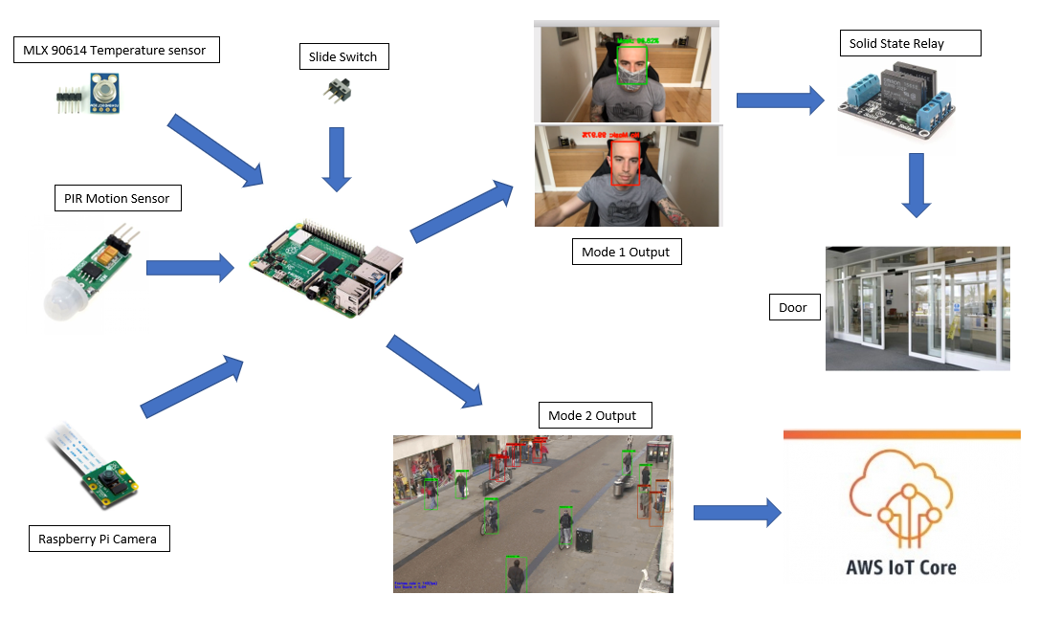

*Architecture Diagram*

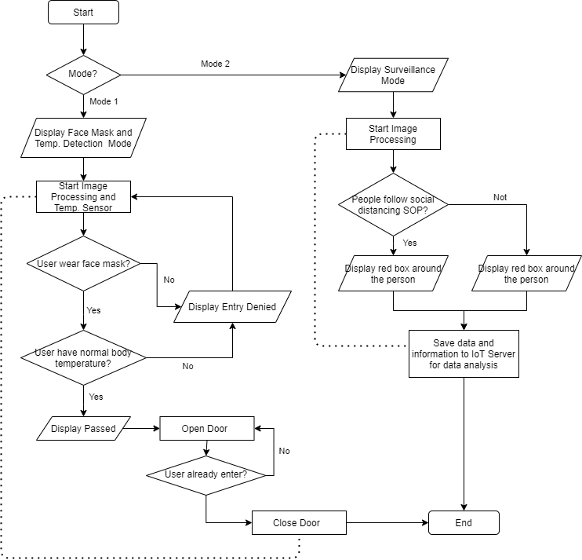

*Program Flow / Block Diagram*

c) 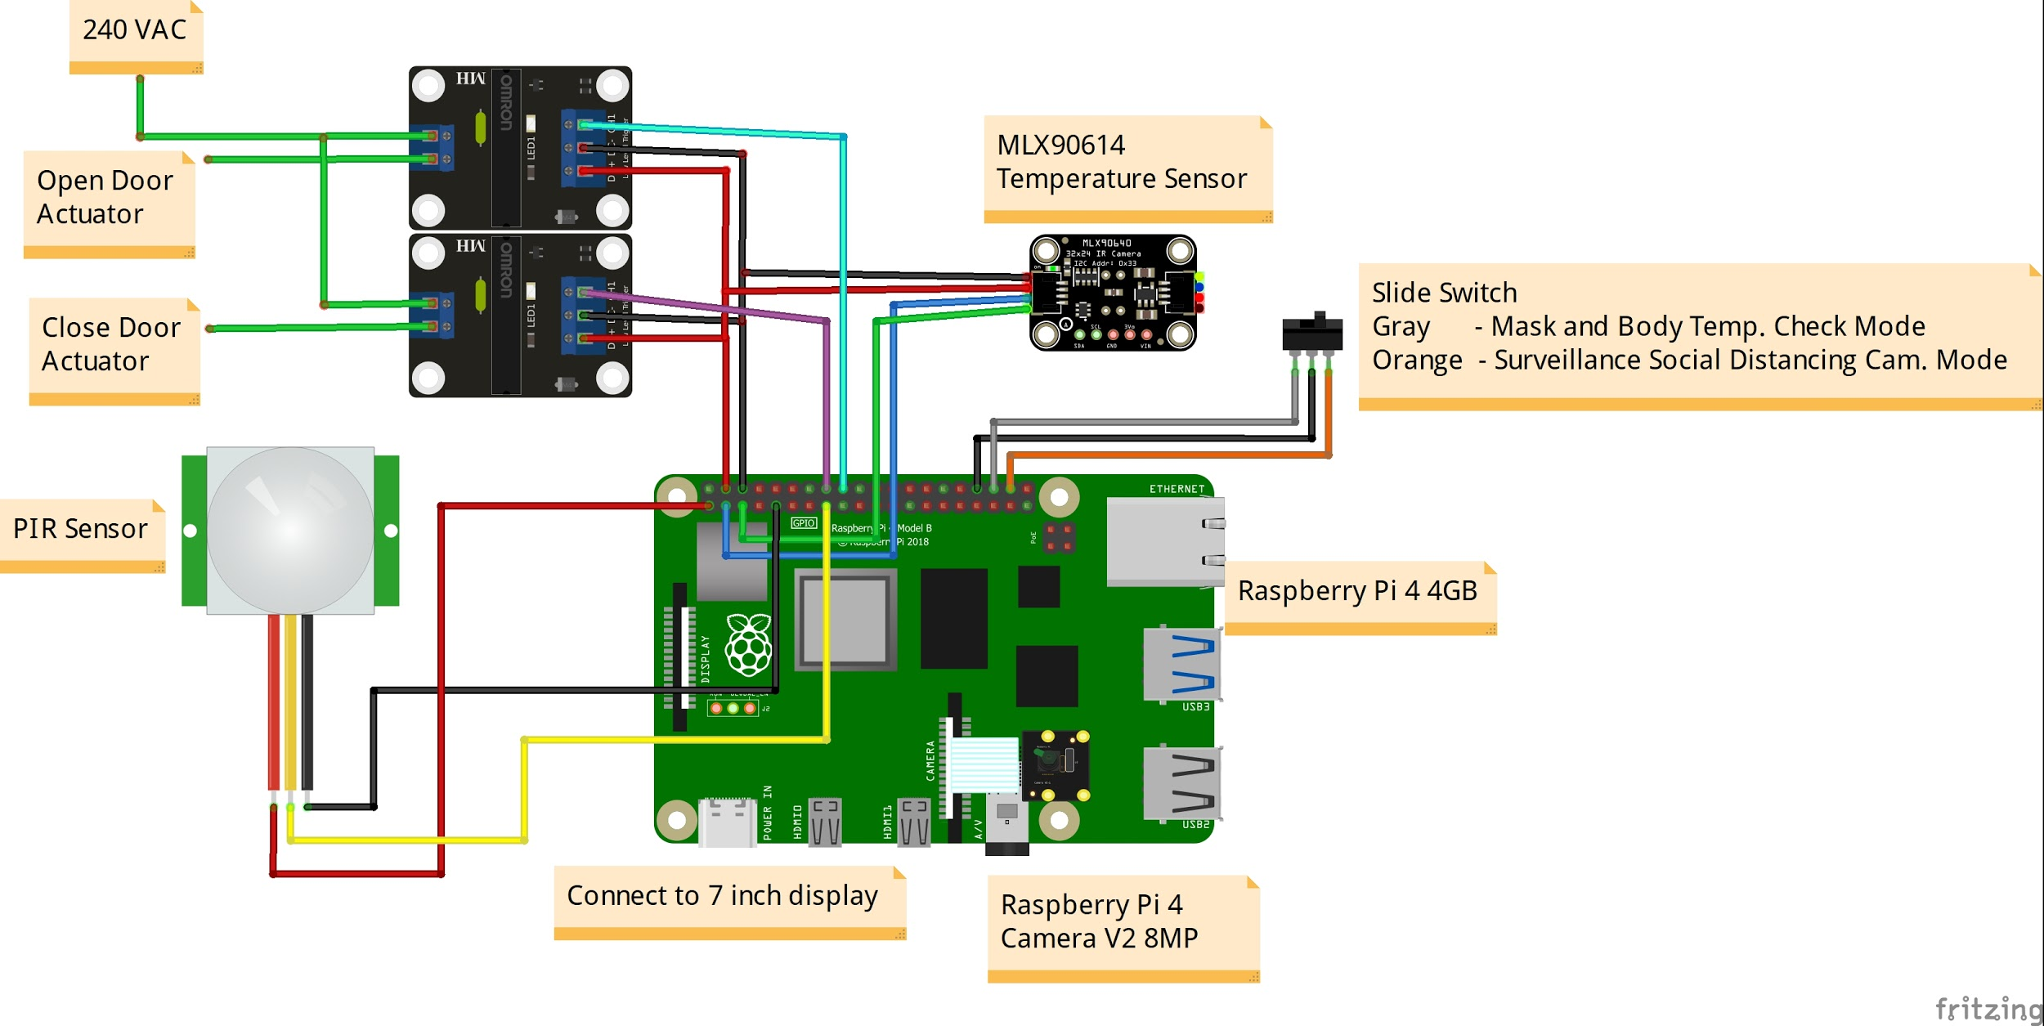

*Circuit Connection Diagram*

Raspberry Pi Sensor Pin connection:

Camera : Camera Serial Interface (CSI) Port

Slide Switch : Mode 1 - GPIO 16

Mode 2 - GPIO 20

PIR Sensor : GPIO 22

MLX90614 Temperature Sensor : SDA: SDA GPIO 2

SCL: SCL GPIO 3

Solid State Relay : Open Door: GPIO 24

Close Door: GPIO 23

d) 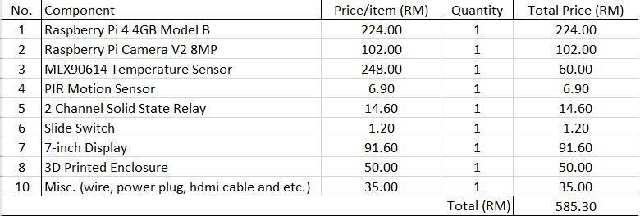

Material Reference

1. Raspberry Pi 4 4GB

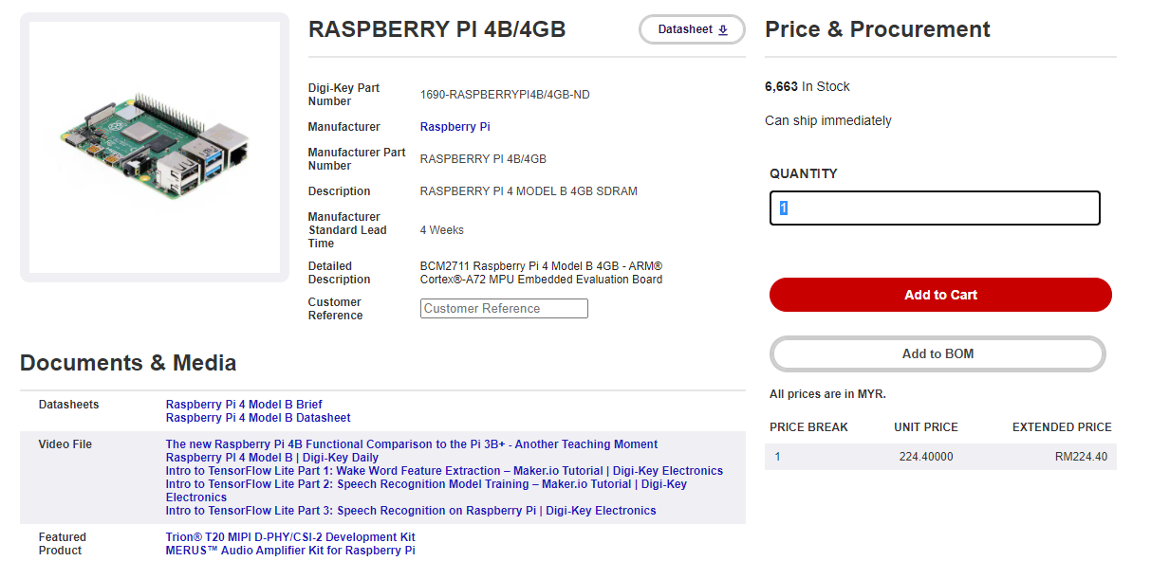

2. Raspberry Pi Camera V2 8MP

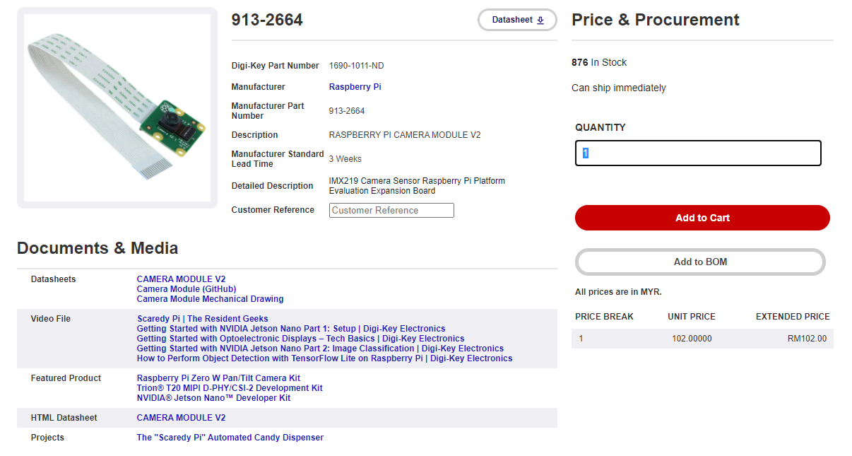

3. MLX90640 Thermal Camera

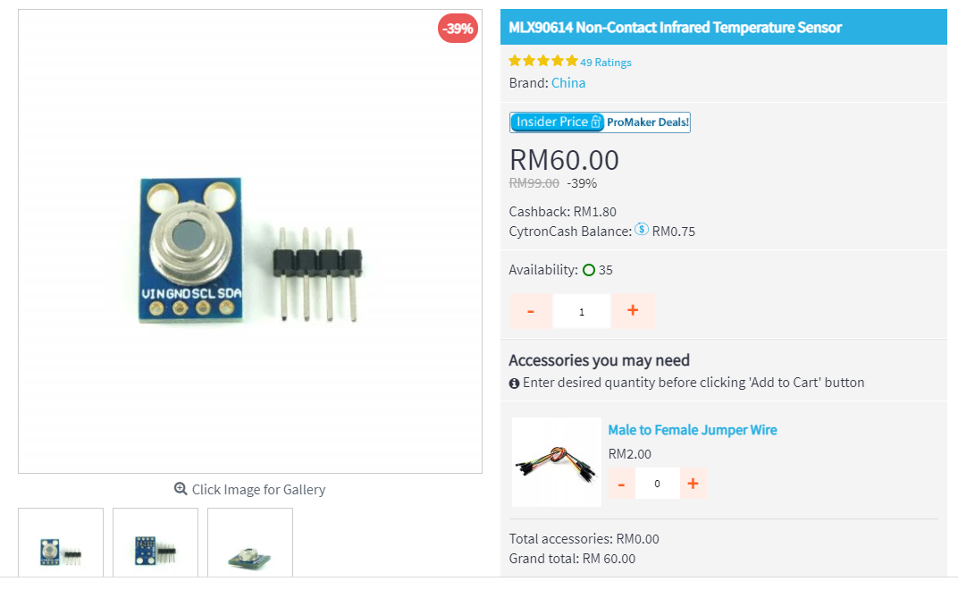

4. 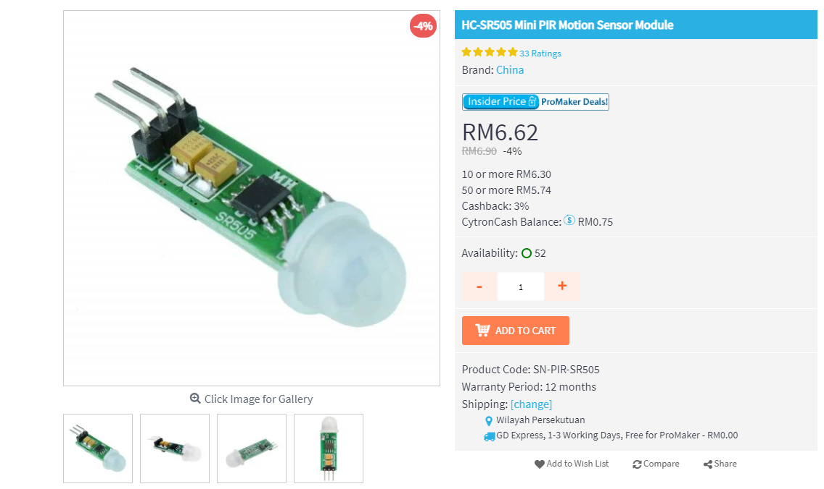

5. 2 Channel Solid State Relay

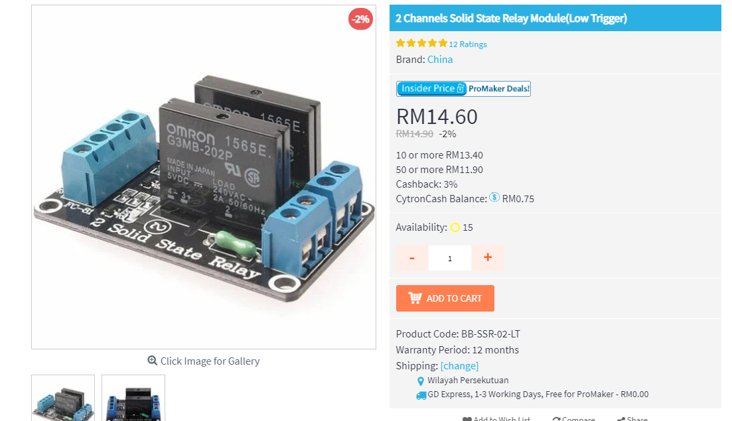

6. Slide Switch

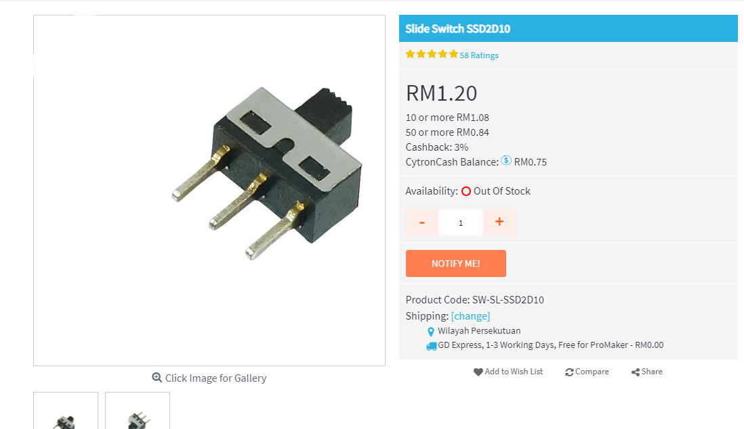

7. 7-inch Display

